PROJECT REPORT OF INDUSTRY ORIENTED HANDS ON EXPERIENCE (IOHE)
ON
2D Game Asserts
submitted in partial fulfilment of the requirements for the award of degree of

BACHELOR OF ENGINEERING
In
COMPUTER SCIENCE AND ENGINEERING

Submitted by: Supervised By:
Vansh Jindal CEO
2211981450 Game Artist
ZenVara Infotech LLP


DEPARTMENT OF COMPUTER SCIENCE AND ENGINEERING

CHITKARA UNIVERSITY INSTITUTE OF ENGINEERING AND TECHNOLOGY
CHITKARA UNIVERSITY, PUNJAB, INDIA

Acknowledgement

I would like to express my sincere gratitude to Dr. Parthasarathy P K, Head of the Game Design Department, for his valuable guidance, support, and encouragement throughout my internship.
I am also thankful to Zenvara Infotech LLP for providing me with the opportunity to work as a 2D Artist, where I gained practical exposure to real-world game asset creation.
Lastly, I would like to thank Chitkara University for providing the platform to enhance my skills and knowledge through this internship.

Preface

This report presents the work completed during my internship as a 2D Game Artist at Zenvara Infotech LLP. The purpose of this internship was to gain practical experience in designing game assets and understanding industry workflows.
During this internship, I worked on creating visual assets for games such as Bubble Spinner and Sea Animal Merge Game, using tools like Adobe Photoshop and Adobe Illustrator.
This report highlights the learning experience, tools used, design process, and key outcomes of the internship.

Contents

- Introduction to Internship – Page 1
- Feasibility Study / Technologies Studied – Page 2
- Requirement Analysis / Projects – Page 3
- Modules Completed / Key Takeaways – Page 4
- Detailed Analysis – Page 5
- Design (Flowcharts, Diagrams) – Page 6
- Outputs – Page 7
- Bibliography & References – Page 8

Introduction to Project / Internship

The internship was completed at Zenvara Infotech LLP, where I worked as a 2D Game Artist in the Game Design domain.
The main objective of the internship was to design visually appealing and functional game assets for mobile and casual games. My role involved creating UI elements, game objects, characters, and visual components.
During the internship, I contributed to the development of the following games:
- Bubble Spinner Game
- Sea Animal Merge Game
The work required creativity, understanding of game aesthetics, and knowledge of digital design tools.

Feasibility Study / Technologies Studied

Technologies & Tools Used:
- Adobe Photoshop
- Adobe Illustrator
Feasibility Study:
The project was feasible due to:
- Availability of industry-standard tools (Photoshop & Illustrator)
- Clear design requirements for casual games
- Scope for creative asset design without heavy technical dependency
Why These Tools?
- Photoshop: Used for raster graphics, textures, and visual effects
- Illustrator: Used for vector-based assets and scalable designs

Requirement Analysis / Projects

Project 1: Bubble Spinner
- Design colorful bubbles and spinning elements
- Create smooth and visually attractive UI
- Maintain consistency in colors and shapes
Project 2: Sea Animal Merge Game
- Design sea animals (fish, turtles, etc.)
- Create merge progression visuals
- Maintain a playful and engaging underwater theme
Requirements:
- High-quality 2D assets
- Game-friendly color palettes
- Optimized designs for performance
- Consistent art style

Modules Completed / Key Takeaways

Modules Completed:
- Asset Design for Bubble Spinner
- Asset Design for Sea Animal Merge Game
- UI Elements Creation
- Icon & Object Design
Key Takeaways:
- Improved creativity and design thinking
- Learned industry workflow for game asset creation
- Better understanding of color theory and composition
- Hands-on experience with Photoshop & Illustrator
- Learned consistency in game art style

Detailed Analysis of Internship

During the internship, I focused on designing assets that align with game requirements and user experience.
Bubble Spinner Analysis:
- Focus on vibrant colors and circular symmetry
- Designed smooth and visually satisfying spinning elements
Sea Animal Merge Game Analysis:
- Designed cute and appealing sea creatures
- Focused on progression-based visual design
- Maintained underwater theme consistency
Overall Learning:
- Understanding user engagement through visuals
- Importance of simplicity in casual games
- Asset optimization for performance

Design (Flowchart / Context Diagram)

Idea → Concept Sketch → Design in Illustrator/Photoshop → Refinement → Export Assets → Implementation in Game

Basic Flowchart:

Start
↓
Understand Game Requirement
↓
Create Initial Design
↓
Refine & Improve Design
↓
Finalize Asset
↓
Export & Deliver
↓
End

Output
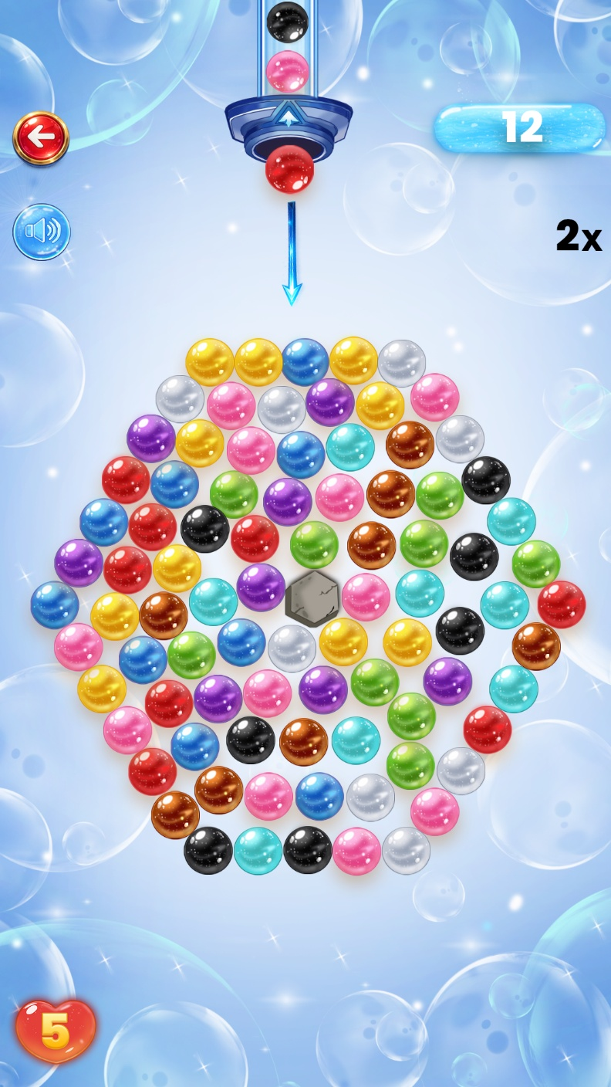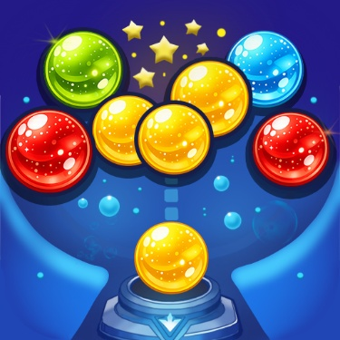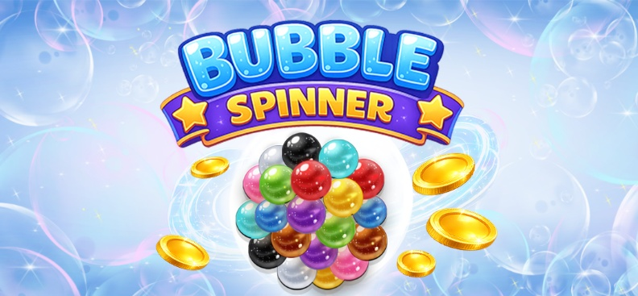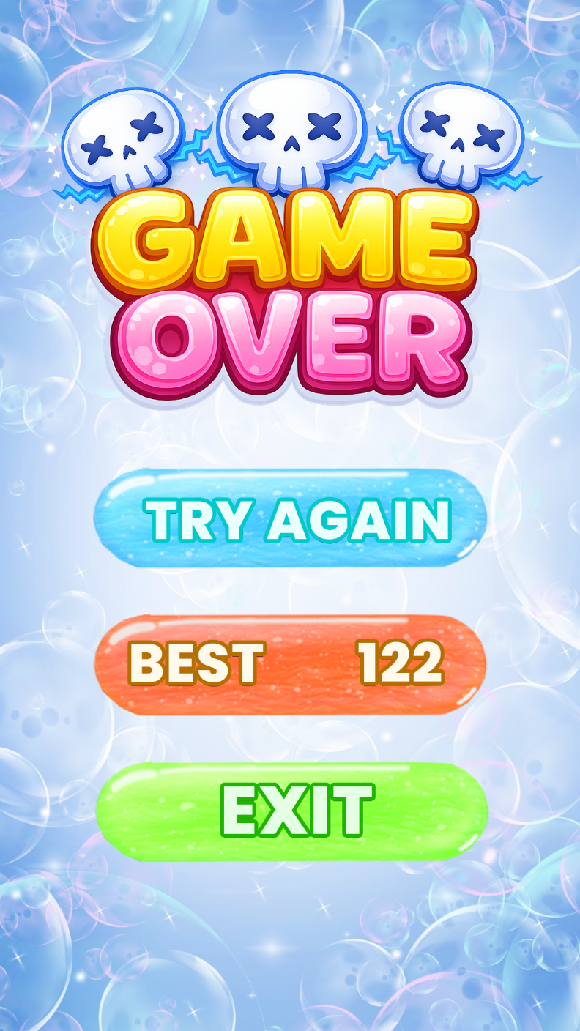
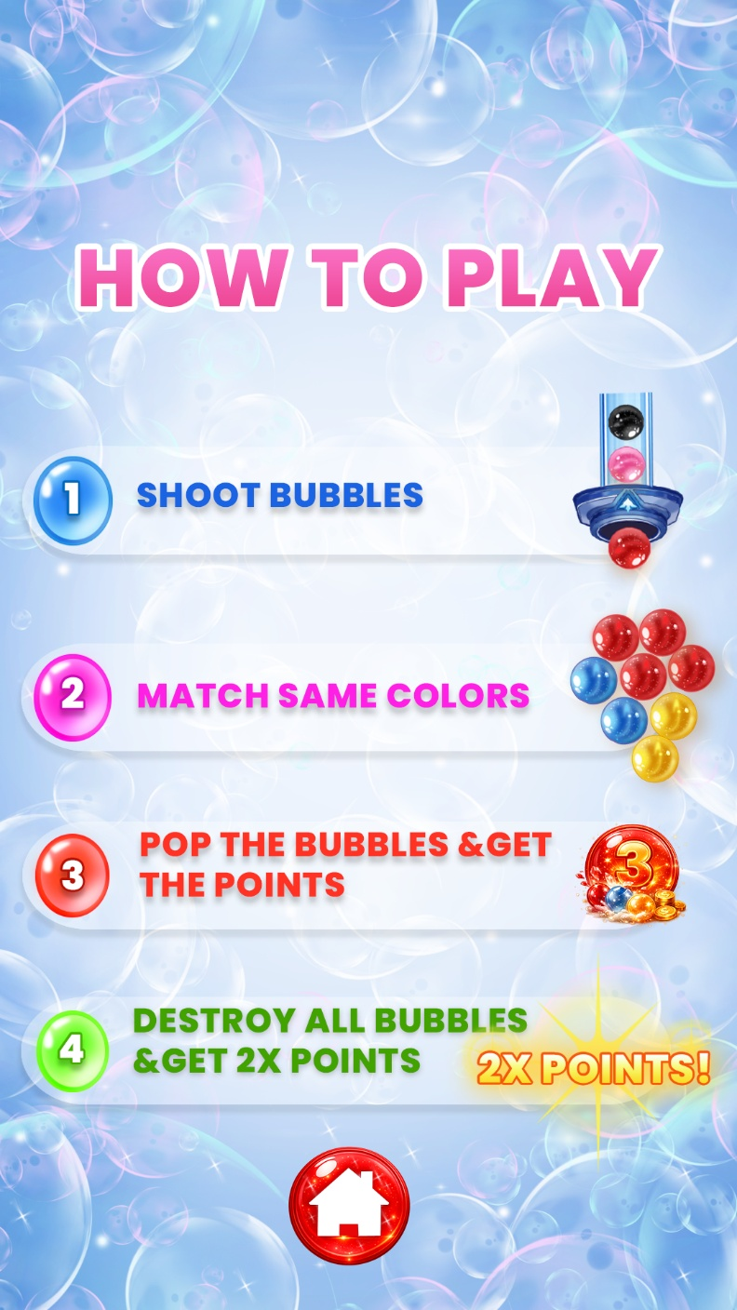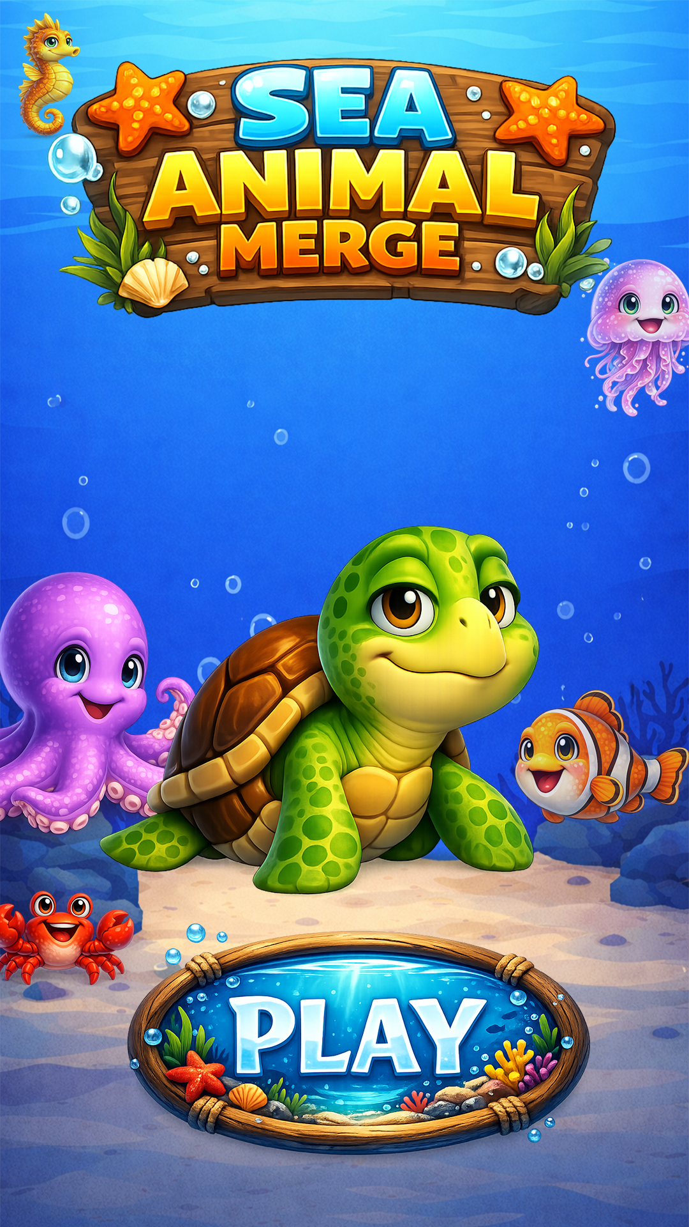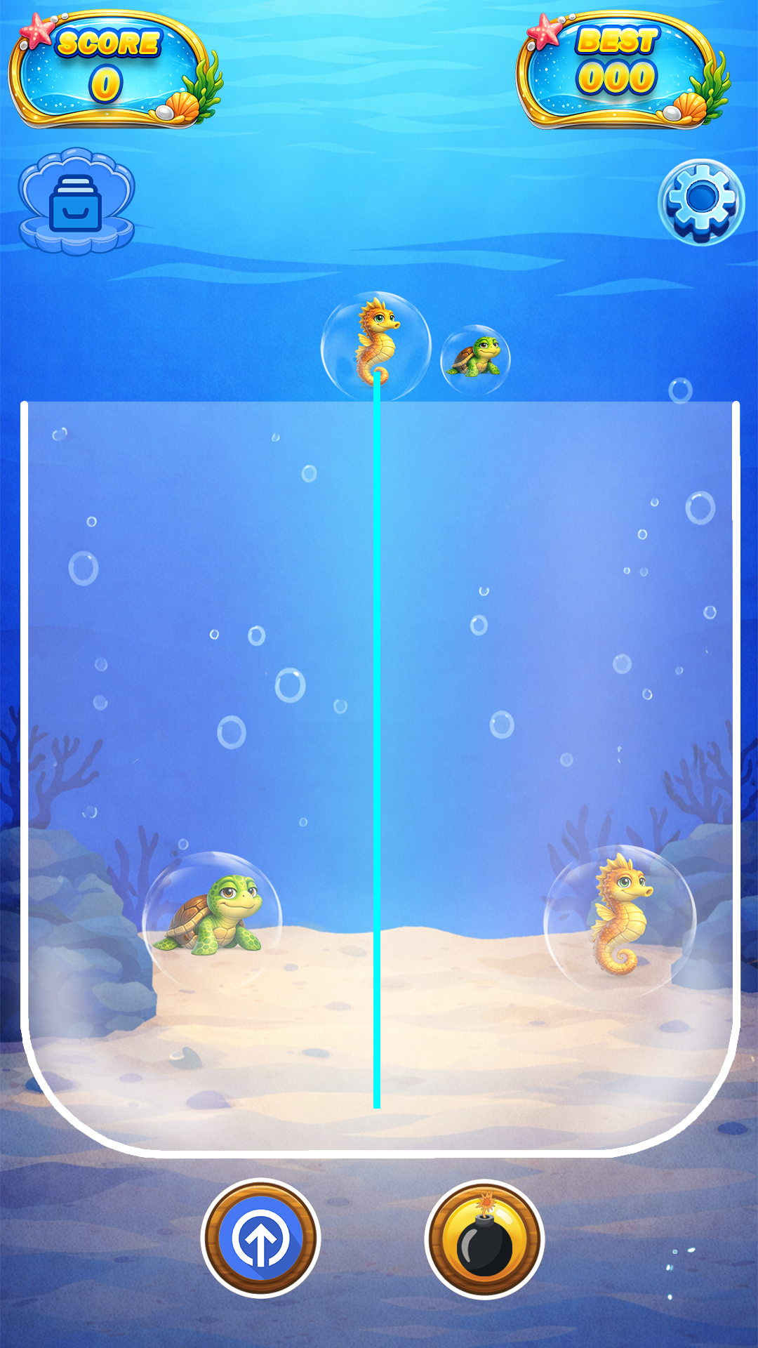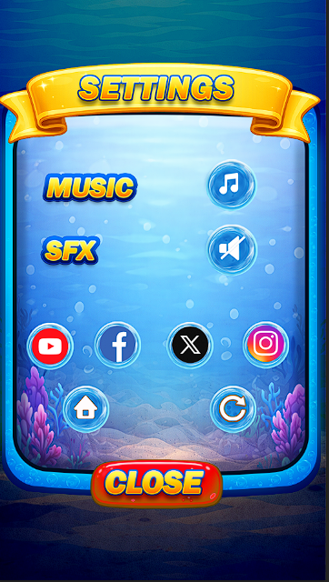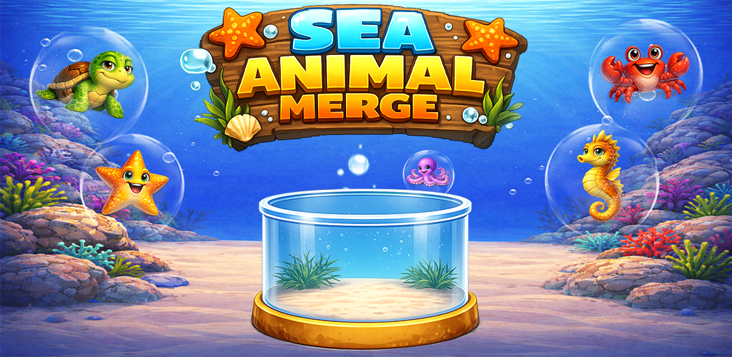

Bibliography and References

Websites:
- https://www.adobe.com
- https://www.behance.net
- https://dribbble.com

